Getting Started
Installing Developer’s Tools
(Updated May 2005)
This documentation provides information on installations of programs and tools required for various development tasks.
Required Tools 1
Java JDK 5.0 1
Ant 1.6.2 2
MySQL 4.1 2
DbVisualizer 3
Tomcat 5
Source Control 6
To Install WinCvs 6
To Install Tortoise 7
Eclipse (and Checkstyle plug-in) 7
Optional Tools 13
Cygwin 13
What Is Cygwin? 13
Apache 13
Python 13
Using PhpMyAdmin with MySQL 13
Thunderbird for Email 15

Required Tools

Java JDK 5.0
- Go to http://java.sun.com/j2se/1.5.0/download-netbeans.html to download JDK 5.0 Update 2 with NetBeans 4.0.
- Open the downloaded file. Follow on-screen instructions to proceed with installation. Install under a simple directory name, e.g. “C:\apps\java”, “C:\apps\netbeans”.
- Set JAVA_HOME environment variable :
  - My Computer, right click, Properties
  - Advanced Tab, Environment Variables
  - Click New under ‘System variables’
    - Variable Name: JAVA_HOME
    - Variable Value: C:\apps\java
  - Ok, Ok, Ok
Note: Requires Reboot
Note: Netbeans is not necessary for Data Shop development, but it is used by CTAT.

Ant 1.6.2
- Go to http://archive.apache.org/dist/ant/binaries/, look for the link for “apache-ant-1.6.2-bin.zip”.
- Install to a simple location, e.g. “C:\apps\ant”.
- Add ant to your path and an ANT_HOME environment variable:
  - My Computer, right click, Properties
  - Advanced Tab, Environment Variables
  - Select Path under System Variables, and click Edit
    - Add “;C:\apps\ant\bin” to the end
    - Ok
  - Click New under ‘System variables’
    - Variable Name: ANT_HOME
    - Variable Value: C:\apps\java
    - Ok
  - Ok, Ok

MySQL 4.1
- Go to http://dev.mysql.com/downloads/mysql/4.1.html. Look for Windows Downloads. Click on “Pick a mirror” for the second row “Windows (x86)” to pick a mirror and start the download.
- Unzip the installed file. Double-click on “Setup.exe”.
- Install to simple location, e.g. C:\apps\mysql
- Skip the signup at mySQL.com
- Run the ‘MySQL Server Instance Configuration Wizard’
  - Be sure to check ‘Install as Windows Service’.
  - And check ‘Include Bin Directory in Windows PATH’
- Create the analysis database:
  - Open a command prompt.
  - mysql –u root mysql
mysql> create database analysis_db;
Query OK, 1 row affected
mysql> exit;
Bye
- Create the ‘datashop’ user:
  - If you changed the root password, do this step on the command line or modify the bat file.
  - In Windows Explore, go to DataShop\java\sql
  - Double click on add_datashop_user.bat
- Create the tables and load sample data:
  - In Windows Explorer, go to DataShop\data\ctat\two_lc_test
  - Double click on two_lc_test.bat

DbVisualizer
- Download from http://www.dbvis.com/products/dbvis/install/install.jsp
- Unzip the downloaded file. Open DbVisualizer.
- Right click on Connections, Create Database Connection.
- Give the connection a name, e.g. <your hostname>, and then Click the Edit button to specify the JDBC connector.
- Select MySQL connector.
- Click on the folder icon in the User Specified tab of Driver File Paths.
- Navigate to DataShop/java/extlib directory and select mysql-connector-java-3.0.15-ga-bin.jar
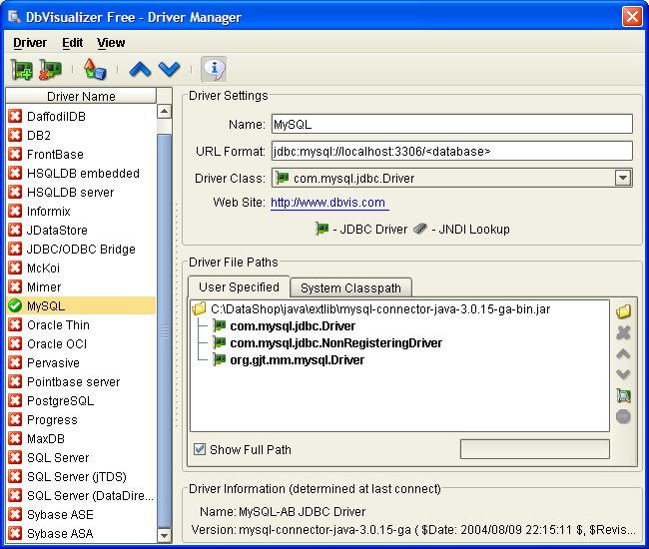
- Now, close the Driver Manager dialog by clicking on the X, top right.
- Select MySQL in the Driver (JDBC) drop down list. Be sure you see a green checkmark next to it.
- Set the Database URL to ‘jdbc:mysql://localhost:3306/analysis_db’
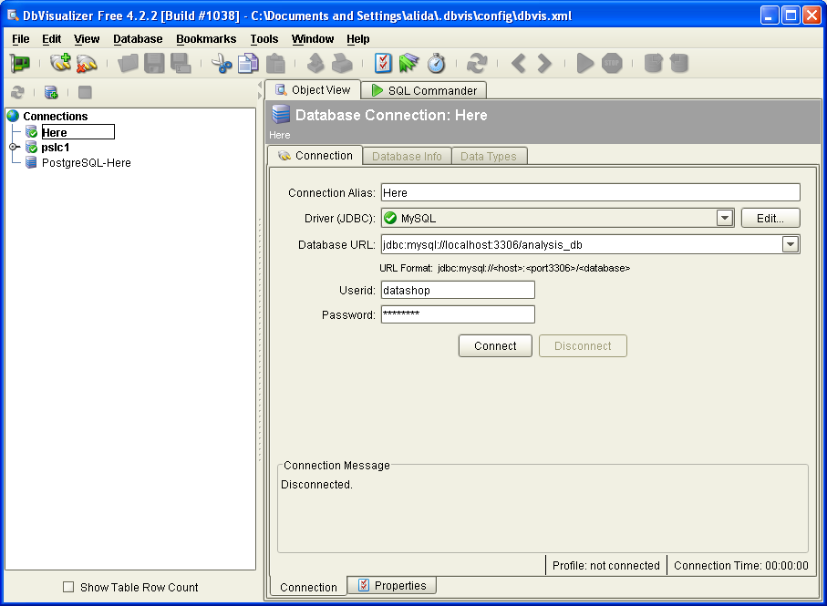
- Try Connect, if it is successful, the databases or tables will populate on the left-hand side.
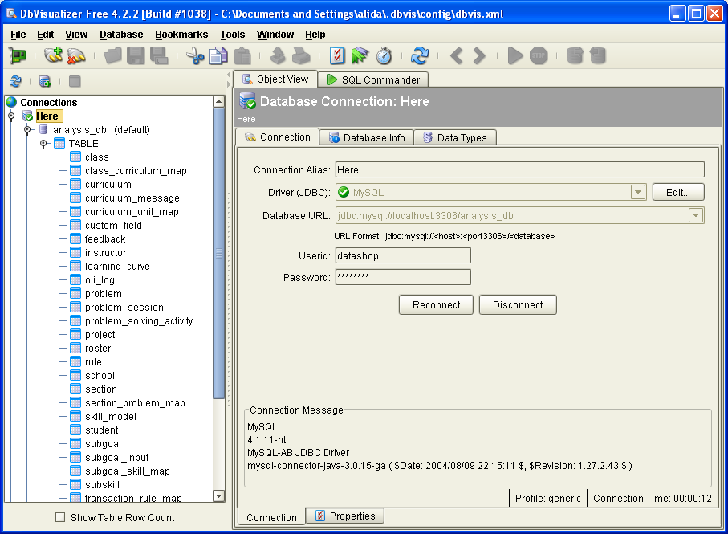

Tomcat
- Go to http://jakarta.apache.org/site/downloads/downloads_tomcat-5.cgi.
- Under ‘5.5.9 -> Binary’, click on ‘5.5.9.exe’, and save to your local hard drive.
- Double-click on the downloaded installer file
- Be sure to install Tomcat as a service
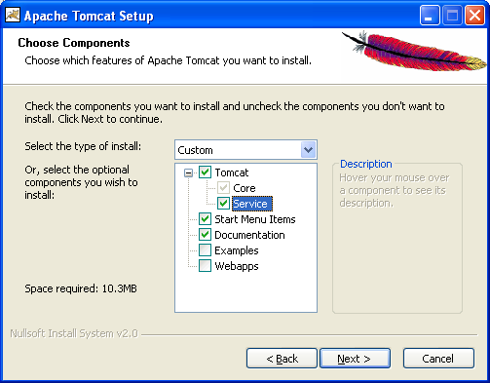
- Choose Install Location under a simple directory name, e.g. C:\apps\tomcat”.
- Leave configuration of HTTP/1.1 Connector Port as 8080
- Java Virtual Machine, e.g. C:\apps\java\jre
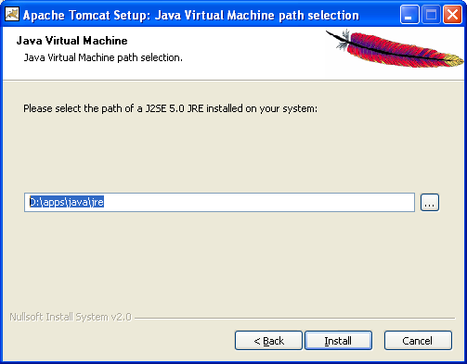
- Verify that Tomcat is started and is installed as a service by opening the services dialog:
  - Start menu, Settings, Control Panel
  - Administrative Tools, Services
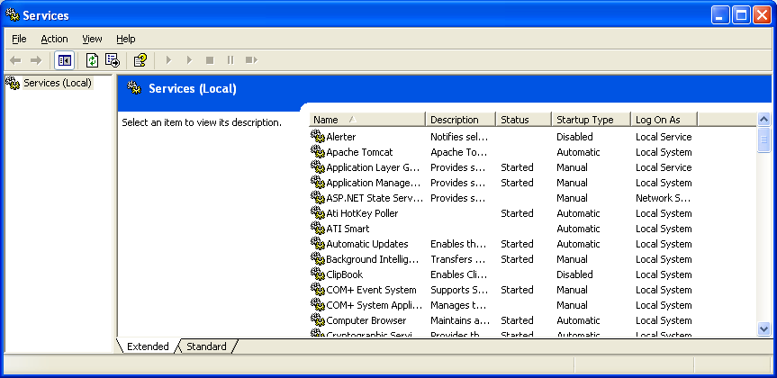

Note: This release of Apache Tomcat was packaged to run on J2SE 5.0 or later. It can be run on earlier JVMs by downloading and installing a compatibility package from the Apache Tomcat binary download page.

Source Control
At this point, you should get the source code for the Data Shop. You can either install WinCvs or Tortoise to access the DataShop module in cvs.

To Install WinCvs
- To download WinCvs, go to http://www.wincvs.org/download.html. Click on “Download installer” for WinCvs 2.0.0.2.
- Unzip the downloaded file. First, open wincvs_setup.exe.
- Follow on-screen instructions to proceed with installation. Install the program into “C:\apps\wincvs”.
- Go back to the extracted files. Open cvsnt_setup.exe.
- Follow on-screen instructions to proceed with installation. Install the program into “C:\apps\cvsnt”.
- Set CVSROOT:
  - Protocol: pserver
  - Repository Path: /usr0/local/cvsroot
  - Set Username to the user name you asked for
  - Hostname: pact-cvs.pact.cs.cmu.edu

To Install Tortoise
Ask Ben and document how it done in this file.

Eclipse (and Checkstyle plug-in)
- Go to http://www.eclipse.org/downloads/index.php and click on the link to proceed to download Eclipse SDK 3.0.2.
- Unzip the downloaded file and put it under “C:\apps”.
- Set up Eclipse
  - Run Eclipse
  - Select File > New > Project…
  - Select CVS > Checkout projects from CVS. Click Next.
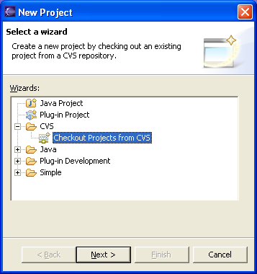

  - Input the host and login information as follows, and then click Next.
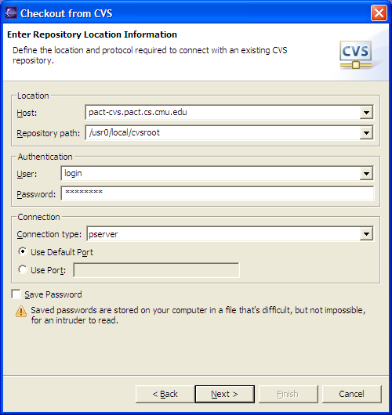

  - Check “Use an existing module” and select “DataShop” from the list. Click Next.
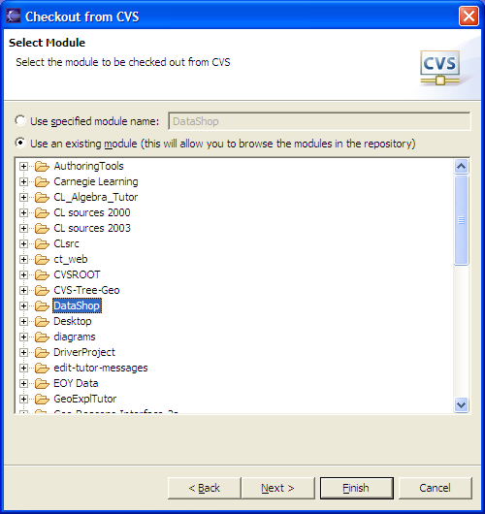

  - Leave the first option checked: “Check out as a project configured using the New Project Wizard”. Click Next.
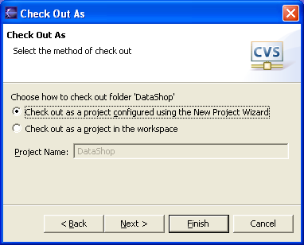
  - Select the Head tag. Click Finish.
  - In the “New Project” dialog, select “Java Project” and click Next.
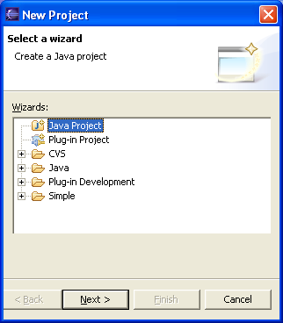
  - Check ‘Create project at external Location’ option and input the Project Name and the directory where you have already put the CVS repository.
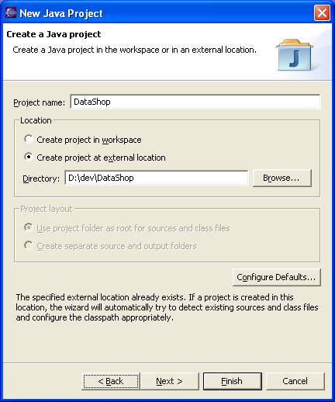
  - CVS files will load. Leave all as default and click Finish.
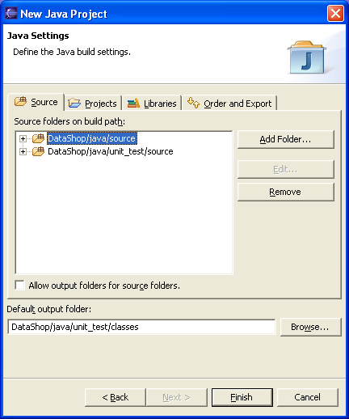
  - Make sure to have NO tabs and that displayed tabs are set to 8 spaces.
    - Where do we set the tab thing?
    - Preferences -> Java -> Editor -> Appearance
      - Displayed tab width: 8

- Set up the Eclipse Checkstyle Plug-in
  - Close Eclipse.
  - Go to http://sourceforge.net/project/showfiles.php?group_id=80344. Download the zip file for Eclipse Checkstyle Plug-in v4.0.0 beta1.
  - Unzip the downloaded file. Copy and paste the “com.atlassw.tools.eclipse.checkstyle_4.0.0” folder into the “plugins” folder, which is located under the directory where you installed Eclipse.
  - Run Eclipse. Select Window > Preferences. There should be a Checkstyle option in the left side menu.
  - Click on “New…” button on the right-hand side, specify:
    - type: “Project Relative Configuration”
    - name: “DataShop Checkstyle”
    - location: within the DataShop CVS directory, “documentation/DevelopersInfo/CheckstyleCheckstyleConfig.xml”
    - Ok, Ok
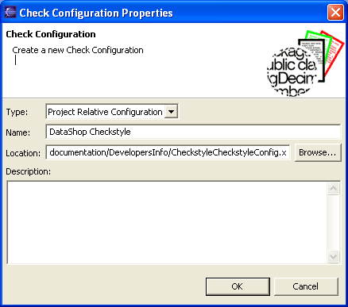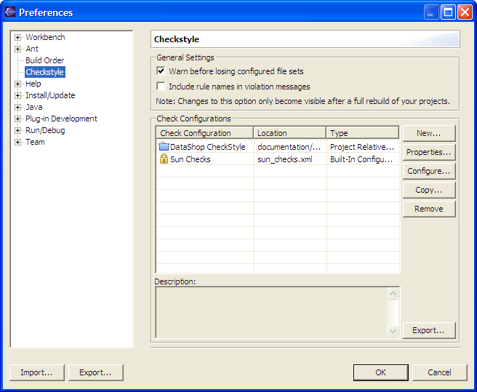
  - Open the project that has been created previously in the DataShop directory. Go to Project > Properties, locate Checkstyle option on the left side menu. Check “Checkstyle active for this project”. Select the configuration “DataShop Checkstyle”. Click “OK”.
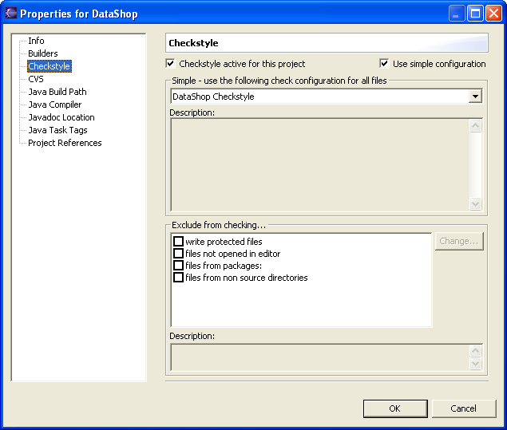

Optional Tools

Cygwin

What Is Cygwin?
Cygwin is a Linux-like environment for Windows. It consists of two parts:
- A DLL (cygwin1.dll) which acts as a Linux API emulation layer providing substantial Linux API functionality.
- A collection of tools, which provide Linux look and feel.
See http://www.cygwin.com/
- Install or update
now!
(using setup.exe)
- Do regular install. (This time keep the default root directory, c:\cygwin)

Apache
- Go to http://httpd.apache.org/download.cgi. Download Apache 2.0.54 from the link “Win32 Binary (MSI Installer)”.
- Run the installer and follow on-screen instructions.
- Install into “C:\apps\apache”.

Python
Install regular install.

Using PhpMyAdmin with MySQL
Install as usual, you will need to change a few files.

- After using the MySQL setup wizard, use the MySQL command line client to change the password to the old, 16 byte hash. Login as root, and type:

set password = OLD_PASSWORD(“password”);

- Open the mysql directory and update my.ini to include the lines:

# Enable old clients that can only send 16 byte password hashes
old_passwords

- Open the config.ini.php file from with the PhpMyAdmin space within Apache htdocs directory.

Set the authtype to cookie ($cfg['Servers'][$i]['auth_type'])
Set the cookie seed ($cfg['blowfish_secret'])
Set the login and password for MySQL

Thunderbird for Email
- Download from www.mozilla.com
- Run installer
- Andrew Email Account Settings
  - Server name: cyrus.andrew.cmu.edu
  - SMTP server: smtp.andrew.cmu.edu
- Andrew LDAP Account Settings
- Set the directory server properties as follows: 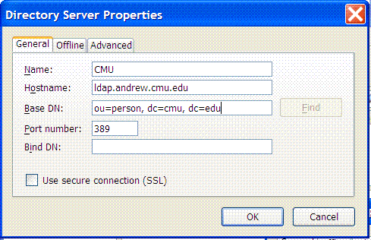
- Set options to populate address fields from LDAP: Tools > Options > Composition > check Directory Server

